ITI – Bash Scripting Lab 1
Mohammad Tarek – Data Management

- Using sed utility
- Display the lines that contain the word “lp” in /etc/passwd file.
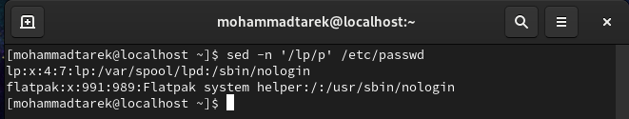
- Display /etc/passwd file except the third line.
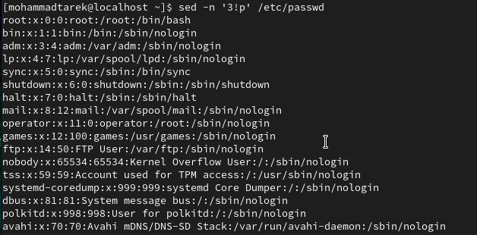

- Display /etc/passwd file except the last line.
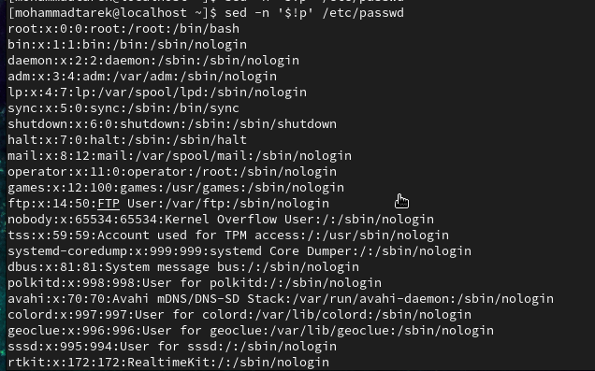
- Display /etc/passwd file except the lines that contain the word “lp”.
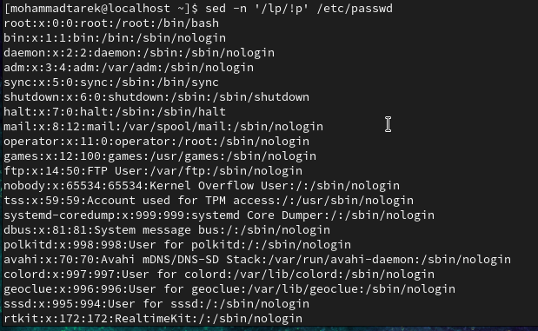
- Substitute all the words that contain “lp” with “mylp” in /etc/passwd file.
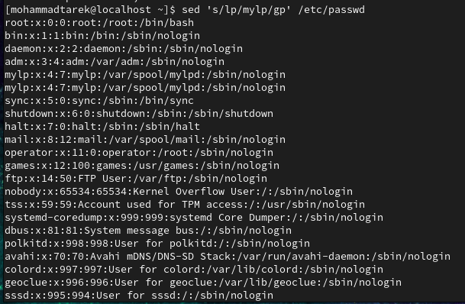
- Using awk utility
- Print full name (comment) of all users in the system.
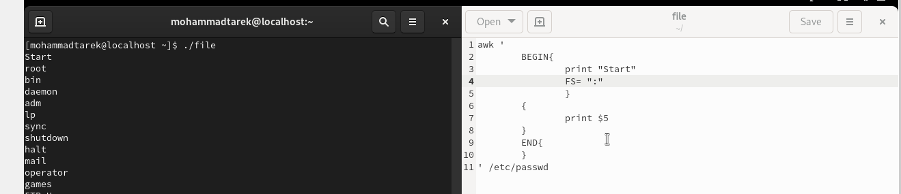
- Print login, full name (comment) and home directory of all users.( Print each line preceded by a line number)
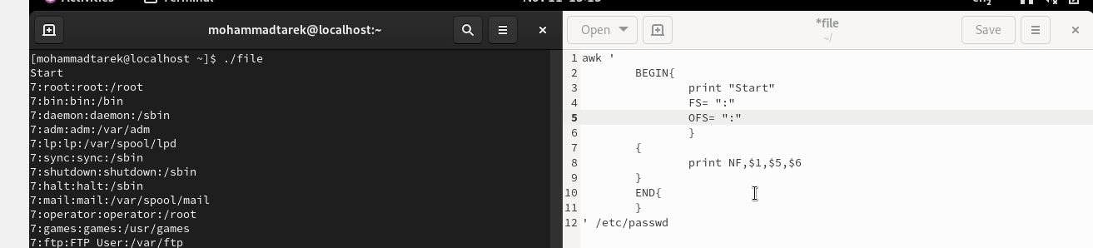
- Print login, uid and full name (comment) of those uid is greater than 500
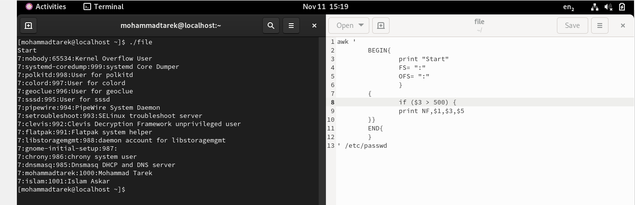
- Print login, uid and full name (comment) of those uid is exactly 500
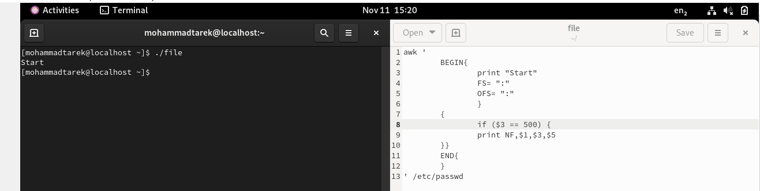
- Print line from 5 to 15 from /etc/passwd
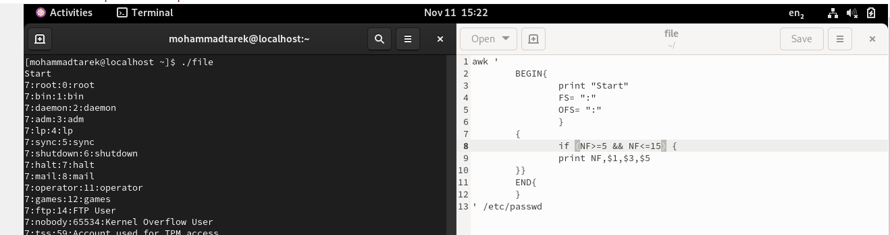
- Change lp to mylp
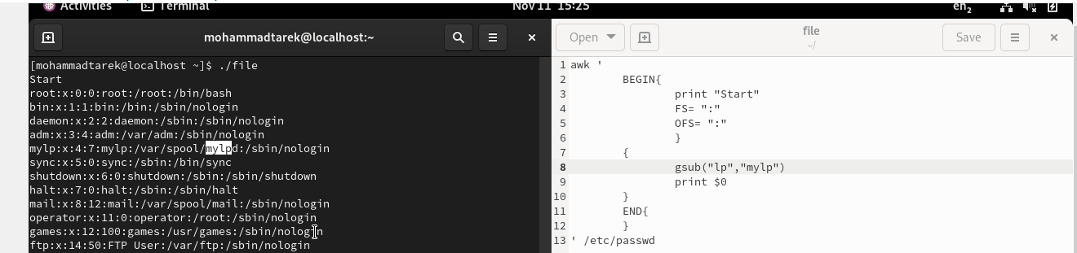
- Print all information about greatest uid.
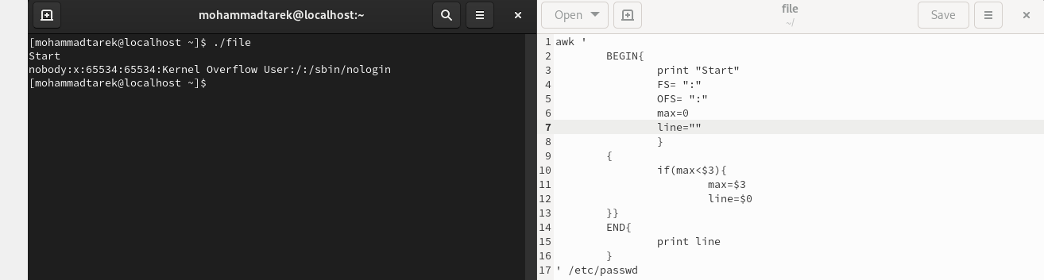
- Get the sum of all accounts id’s.
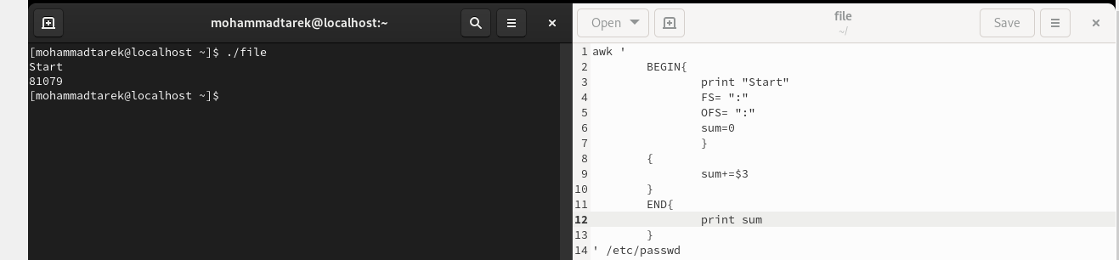
- Bonus
- Get the sum of accounts id’s that has the same group.
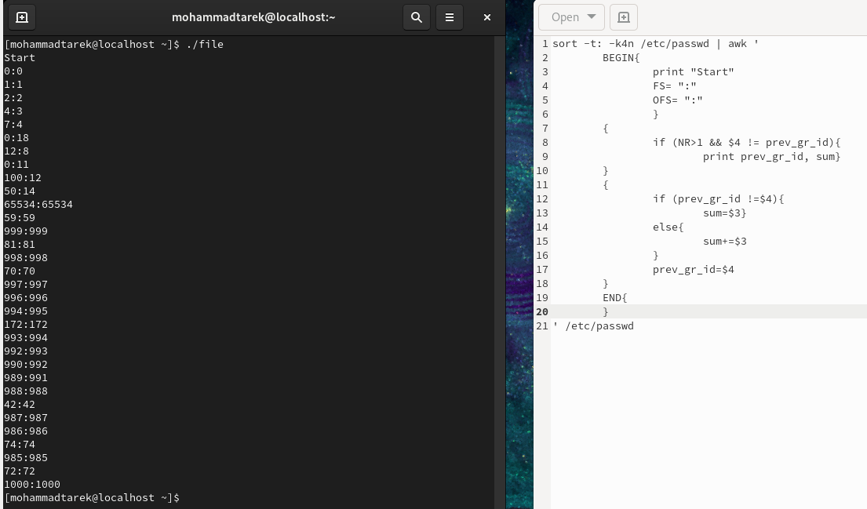

- Make the following report:
